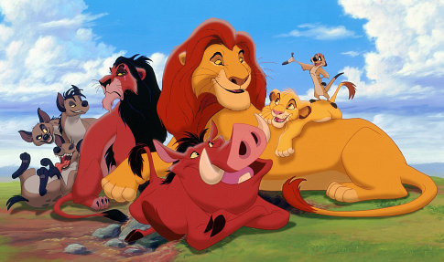

Name ___________________ Period___
1-3 Draw a food chain at least three members long consisting of living things in the movie.
---------> --------> -------->
4-6. Identify the producer, the first level consumer, and second level consumer in the food chain.
7-21 A Balanced Ecosystem
Fill in the chart with living things found in and around Pride Rock. Put them in their proper group. You must have 15 for full credit and you need an organism in every column
Decomposer | Producer | Herbivore | Carnivore | Omnivore

Identify 3 biotic factors from the movie Identify 3 abiotic factors from the movie
22. 25.
23. 26.
24. 27.
28-30. Name three different biomes that you saw Simba in.
31-36 . Name 2 characteristics that allowed you to identify the biome
Biome Name | Characteristics of the Biome
28. | 31. 32.
29. | 33. 34.
30. | 35. 36.
37-38. In the beginning of the movie Scar is about to eat a mouse. Identify the:
37. Predator______________ 38. Prey _______________
39. When explaining the Circle of Life Mufasa says to Simba, "When we die our bodies become the grass." Name the process that Mufasa is referring to. _____________

40. During the song Oh I Just Can't Wait to Be King" the crocodile has birds in its mouth. This is a symbiotic relationship. What type of symbiotic relationship is it? __________

Describe three scenes from the movie that show the following scavenger behaviors.
41. Consume already dead animal meat.

42. Kill and consume young, sick, or small animals.

43. A pack kills larger weakened animals.

44. Name the animal that says, "No wonder we're dangling at the bottom of the food chain."
_____________________ said it.
45. Are they really at the bottom of the food chain? Yes No Explain.
46. When Simba falls from exhaustion what animals begin to encircle him? _________

47. What is the nutritional role of the animal in #46. _________________________
48-50. When Scar replaces Mufasa the pride's stable ecosystem is replaced by an unstable ecosystem. Describe three ways the movie indicates this change in the ecosystem.
48.
49.
50.
51. Puma asks Simba, "What's eating you?" Timone jokes, "Nothing, he's at the top of the food chain!" What does Timone mean?
52. Serabi is summoned by Scar and reprimanded for not providing food. She says, "The herds have moved on. It is over. There is nothing left. We have only one choice, we must leave Pride Rock." How does this quote support the concept that "Flora dictates Fauna? (Plant life determines animal life.)
53. During the final scene, lighting strikes the Pride Land igniting a fire that burns out the existing dead brush and trees. This fire stands for the end of an era of an unstable ecosystem. As time passes, Pride Rock is transformed back into a healthy climax community. What ecological word describes this change in an ecosystem? _________________________
54. Who replaces Scar as the leader of the pride? _____________________

