Food Web ............................................................................Name _____________________________________
1. For the food web, label each organism: (Some may have more than one label)
P = producer 1 = Primary Consumer 2= Secondary Consumer 3 = Tertiary Consumer
2. Now label each animal as either a : H = herbivore C = carnivore O = omnivore
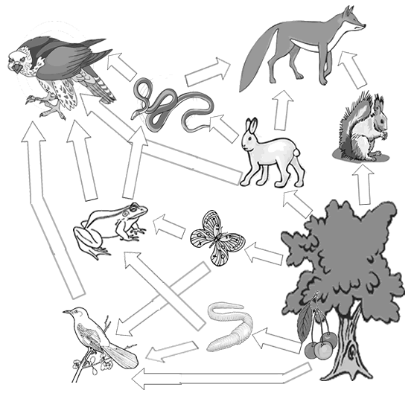
4. Create your own food web on the back. You do not need to draw pictures, you could just write the words. Animals to put on your web: MOUSE, CORN, BLUEBIRD, KING SNAKE, HAWK, CAT, CRICKET

