Exit Slip Scale Problem:
Shown below are two types of scales commonly used in the classroom --a spring scale (left) and a simple balance beam scale on the right.
On earth the spring scale reads 100g with an unknown mass attached at the bottom. To balance the scale on the right a 100g mass was also needed.
If we were to take both scales to the moon, what would the spring scale read? How much mass would be needed to balance the 100g mass on the balance beam? Can you explain your answer?
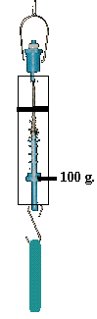 |  | 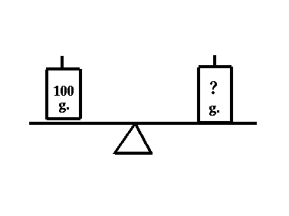
Spring Scale Simple Balance Scale

**Copy and cut questions from next page to make exit slips for students.

1. On the Moon the spring scale on the left would read _______________________?
2. The balance scale on the right would need ______________________?
3. What is the scale on the left really measuring? (Answer in one word.)
4. What does this experiment demonstrate?
5. So what is really mass and weight if they are not the same thing?

1. On the Moon the spring scale on the left would read _______________________?
2. The balance scale on the right would need ______________________?
3. What is the scale on the left really measuring? (Answer in one word.)
4. What does this experiment demonstrate?
5. So what is really mass and weight if they are not the same thing?

1. On the Moon the spring scale on the left would read _______________________?
2. The balance scale on the right would need ______________________?
3. What is the scale on the left really measuring? (Answer in one word.)
4. What does this experiment demonstrate?
5. So what is really mass and weight if they are not the same thing?

1. On the Moon the spring scale on the left would read _______________________?
2. The balance scale on the right would need ______________________?
3. What is the scale on the left really measuring? (Answer in one word.)
4. What does this experiment demonstrate?
5. So what is really mass and weight if they are not the same thing?

